14.57: The total mass of the lead and wood must be the mass of the water displaced, or

solving for the volume 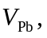
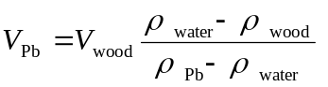
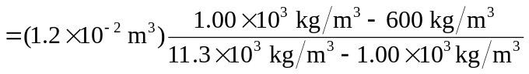
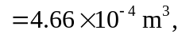

which has a mass of 5.27 kg.

